

**RAPHA EXAMINATIONS BOARD**

e-mail: [raphaexaminationsboard@gmail.com](mailto:raphaexaminationsboard@gmail.com)

contacts: 0778710993/0740540111

**PRIMARY FIVE EXAMINATIONS 2024 (SET 1)**

**SCIENCE**

**Time allowed: 2 hours 15 minutes**

**Pupil’s name:**

**Signature: Date**

**School name:**

**District:**

**READ THE FOLLOWING INSTRUCTIONS CAREFULLY:**

1. This paper has two sections **A** and **B**
2. All the working in both sections **A** and **B** should be shown in the spaces provided
3. All working must be done using blue or black ball point pen or fountain pen.

Diagrams **MUST** be drawn in pencil

1. Unnecessary changes of work may lead to loss of marks
2. Any handwriting that cannot be easily read may lead to loss of marks
3. Do not fill in anything indicated for *examiners use only* and those inside the paper

**For examiner’s use only**

|  |  |  |
| --- | --- | --- |
| **SECTION** | **MARKS** | **INITIALS** |
| **SECTION A** |  |  |
| **SECTION B** |  |  |
| **TOTAL** |  |  |

## SECTION A. (40 MARKS)

1. Suggest **one** way of controlling malaria in a home.
2. Give a reason why animals move from one place to another.
3. Name **one** example of a root crop.
4. Mention any **one** method of preserving food.
5. Name the gas which is used by man for breathing.
6. Give **one** example of an annual crop.
7. Why do we wash our hands after visiting the latrine?
8. On which body part of an insect are legs and wings attached?
9. State any **one** activity done to promote personal hygiene.
10. Give any **one** reason why crop farmers mulch their gardens.
11. Where does a female anopheles mosquito lay its eggs?
12. Mention **one** way of caring for our bodies.
13. Which type of root system do mango plants have?
14. Which part of the body do animals use for hearing?
15. What causes marasmus in young children?
16. Name the garden tool crop farmers use for transplanting seedlings.
17. Write down **one** type of leaves.
18. Name any **one** place where germs can be found.
19. Give **one** reason why we give first aid.
20. State any **one** example of a disease spread by houseflies.
21. Give any **one** raw material plants use to carryout photosynthesis.
22. Give any **one** source of protein nutrients in the diet.
23. Mention **one** way of improving the fertility of the soil.

**P T O**

1. State any **one** danger of too much rainfall to the environment.
2. Which part of a maize grain supplies food to the growing embryo?
3. Name the instrument health workers use to measure the body temperatures of the patients.
4. State **one** importance of food in our bodies.
5. How is ***wind*** different from ***air***?
6. Mention any **one** reason why farmers keep farm records.
7. Why are splints tied around the broken bone of a person’s limb?
8. Which type of family is composed of parents, children and relatives?
9. Name **one** disease which involves the passing out of watery stool.
10. Give any **one** component of the environment.
11. Give **one** example of a domestic bird.
12. Why do people put ventilators on their houses?
13. Name any **one** type of teeth.
14. Mention **one** example of a pet animal kept in our homes.

# Below is a diagram of seed germination. Use it to answer question 38.

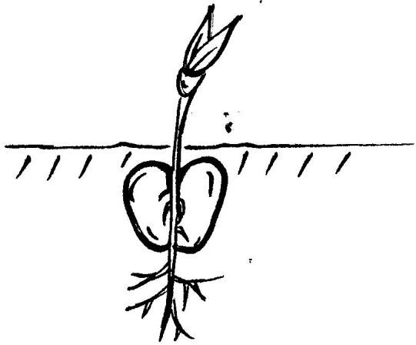

1. Name the type of seed germination shown in the diagram above.
2. Which property of air enables you to drink soda using a straw?
3. How do non- flowering plants reproduce?
4. (a) What is ***pollination***?

## SECTION B. (60 MARKS)

**P T O**

* 1. Write down any **two** agents of pollination.

2. 1. Give any **one** type of pollination.
3. (a) What term is used to describe the condition of the atmosphere at a given period of time?
   1. Name the instrument used to measure the amount of rainfall.
   2. Write down any **two** types of weather.

6. (a) What is ***leaf venation***?



* 1. Which type of leaf venation is shown in the diagram above?
  2. Name any **two** plants which have such leaf venation.

3. (a) Which part of air do plants give out during photosynthesis?
   1. Why is carbondioxide gas used to put off fire?
   2. Mention any **two** properties of air.

6. (a) Apart from panga and hoe, mention any **two** examples of garden tools.

(b) Suggest **two** ways how we can care for our garden tools.



# Match the following in A with those in B.

A **B**

Heart Filtering blood.

Lungs Stores food for few hours.

Kidney Pumping blood.

Stomach Gas exchange.

1. **Heart** :
2. **Tongue** :
3. **Kidney** :
4. **Teeth** :
5. (a) What is ***personal hygiene***?

**P T O**

1. Mention any **two** things that can be used to keep the body clean.

4. How can P.5 pupils promote personal hygiene at school?
5. (a) Name any **one** source of food.
6. Give any **two** examples of food nutrients needed by our bodies.

9. How can we prevent deficiency diseases?
10. (a) Mention **two** examples of crops pests.

(b) Suggest **two** ways of controlling crop pests in the garden.

3. (a) Name the type of soil which has well balanced nutrients.
4. State any **two** uses of soil to people.

7. Mention any **one** object that can be made out of soil.
8. (a) How are toilets and latrines useful in a home?
9. Suggest **two** ways a P.5 pupil can promote the cleanliness of the classroom.

12. Mention any **one** material which can be used in cleaning a classroom.
13. (a) Give any **two** types of soil erosion.


17. Mention any **one** agent of soil erosion.
18. Give **one** way in which soil erosion can be controlled in hilly areas.
19. (a) Name the main natural source of water in the environment.
20. Give **two** uses of water to people.

23. How can water be made safe for drinking?
24. (a) In which season of the year do crop farmers plant their seeds?
25. Apart from planting, state any other **two** activities carried out by farmers on a crop farm.

28. How do crop farmers care for their crops during dry seasons?

# The diagram below shows the life cycle of an insect, use it to answer questions that follow.

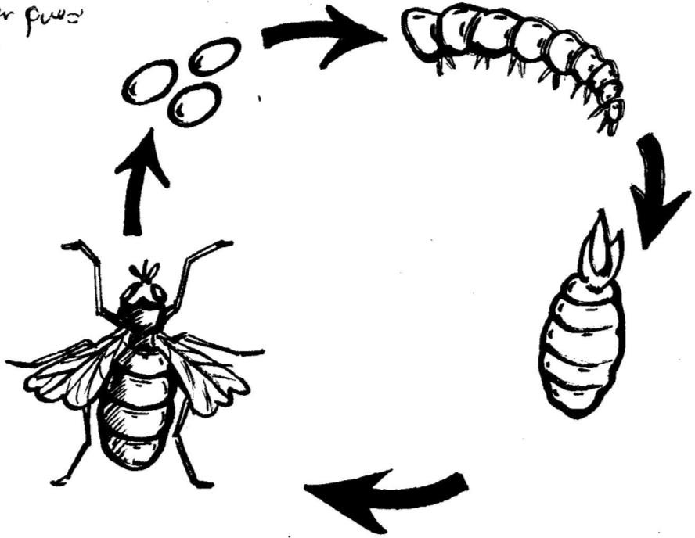

**B**

**A**

**C**

**D**

1. Name the stages marked **A** and **C**.

# A

1. **C**
2. Name the type of lifecycle shown in the diagram above.
3. Mention any **one** insect which undergoes the life cycle above.